Charlotte Curling Association Business Plan

Prepared by:
Omar E. Van Rooyen
Vice President

Charlotte Curling Association
145 B Cupped Oak Drive
Stallings, NC 28104
charlottecurling@gmail.com

September 13, 2014
TABLE OF CONTENTS
Executive Summary - 3 -
Overview Statement - 3 -
Mission Statement and Purpose - 3 -
Business and Organizational Structure - 3 -
Target Market - 4 -
Current Opportunity - 4 -
Projection of Business Future - 5 -
Financial Summary - 6 -
Market Analysis - 7 -
Competitive Analysis - 7 -
Market Segments - 8 -
Entry Barriers - 9 -
Sales and Marketing Strategy - 9 -
Product/Service Strategy - 9 -
Pricing Strategy - 10 -
Recruitment and Retention Strategy - 11 -
Fundraising/Sponsorship Strategy - 12 -
Bonspiel and Special Events Strategy - 12 -
Marketing Strategy - 13 -
Internal Communications Strategy - 13 -
External Communications Strategy - 13 -
Social Media Strategy - 14 -
Website Strategy - 14 -
Branding/Collateral Strategy - 15 -
Differentiation - 15 -
Operations Plan - 15 -
Location - 15 -
Operation - 16 -
Employees - 16 -
Space - 16 -
Capacity - 17 -
Financial System - 17 -
Computer System - 17 -
Tools and Equipment - 17 -
Furniture - 18 -
Displays - 18 -
Permits and Licenses - 18 -
Insurance - 18 -
Financial Plan - 19 -
Capital Budget - 19 -
Operating Budget - 19 -
Revenue - 19 -
Expenses - 20 -
Funding Sources - 20 -
Cash Flow Projection - 20 -
Appendices - 21 -
Appendix 1 – Building Layout - 21 -
Appendix 2 – Six Year Operating Budget - 22 -

Executive Summary

Overview Statement

The Charlotte Curling Association (CCA) is a 501(c)(3) not-for-profit organization founded in Charlotte, NC, in 2010 by individuals interested in the Olympic ice sport of curling. Following the Vancouver Winter Olympic Games, three couples began the organization, which was then and is currently the only curling club in the Charlotte area. One couple provided startup funds, and, with assistance from the Grand National Curling Club, the regional governing body, secured granite stones and other equipment required to play the game. The founding members began to promote and teach the sport, which involves two teams of four attempting to score the most points by delivering their curling stones closest to the center of a target at the opposite end of the ice. Currently, the organization consists of approximately 100 members.

The CCA has been operating for the past four years by renting ice time, first at Pineville Ice House and currently at the Extreme Ice Center in Indian Trail, NC. Ice time has been limited due to commitments to other recreational ice sports, which hinders the organization’s development of youth leagues, disabled leagues, and other programs vital to its mission. This lack of availability combined with less-than-ideal playing conditions, resulting from use of an ice surface not dedicated to curling, has prompted the CCA to build a dedicated curling facility within the Charlotte area. Land has now been purchased for this purpose at 6525 Old Statesville Road, Charlotte, NC 28269, with the goal of opening the facility by November 1, 2014.

Mission Statement and Purpose

The mission of the Charlotte Curling Association is to increase awareness of and participation in the sport of curling and to promote the spirit of curling in the Greater Charlotte community.

By providing a first class sporting experience guided by the positive and motivating spirit of curling, the CCA will foster the growth of the sport among members of the community, including youth, adults, seniors, and those with mental and physical challenges. The organization will develop programs that lead to local, national, and international competition; coordinate and develop interscholastic competition; and create public awareness and appreciation for the sport.

Business and Organizational Structure

The CCA is established as a non-profit corporation in North Carolina and is registered as a 501(c)(3) charitable entity with the Internal Revenue Service.

The association is operated entirely by volunteers, and is managed by a nine-member Board of Directors. Each member is elected for a period of three years at the CCA annual meeting, ensuring that each year three members rotate onto and off of the Board. Following each annual meeting, the Board elects four officers from its members – President, Vice President, Secretary and Treasurer.

As needed, the board will appoint volunteer committee heads, coordinators and representatives for various club positions both from the board and the association at large.

Target Market

Since all CCA curling currently takes place in Indian Trail, with the future location in North Charlotte, the area containing the target market for membership is the greater Charlotte metropolitan area and the surrounding counties in both North and South Carolina. Mecklenburg County alone has a population now exceeding one million, with a median household income of approximately $56,000. A large portion of that population would be able to curl, creating a rather large potential market for the CCA. Curlers are generally between the ages of six and 90 and can be of either gender. Entire families are able to curl together, which presents a unique recreational opportunity for members of the community. The sport can be played by people with a range of athletic ability – from the mildly active to very athletic – and it is a very accessible sport for those with mental and physical disabilities, including but not limited to blindness, deafness, and paraplegia. The CCA fully intends to form leagues for open, men’s, women’s and mixed teams within its membership and also to provide competitive opportunities for K-12 schools, colleges, and disabled persons. The organization will also provide and promote opportunities for corporate and teambuilding events, for which the target market is a broad range of local businesses.

For bonspiels and other events, the target market extends to curlers from clubs across the United States and Canada. The most accessible targets are the curlers from the nearest clubs: the Palmetto Curling Club in Greenville, SC, which is approximately 100 miles from Charlotte; the newly formed Columbia Curling Club in Columbia, SC, which is also approximately 100 miles away; and the Triangle Curling Club in Raleigh, NC, approximately 130 miles from Charlotte. Following the opening of the CCA dedicated facility, it is likely that curlers from Greenville and Columbia will become members of the Charlotte organization. The Triangle Curling Club is also building a dedicated facility, which demonstrates the demand for and growing popularity of curling in the surrounding area. Other curling clubs within the southeastern United States include the Atlanta Curling Club and the Coastal Carolina Curling Club in Wilmington, NC, which are both key targets for event participation.

Current Opportunity

The CCA was established during the 2010 Winter Olympic Games and has expanded rapidly to approximately 100 members. The 2014 Winter Olympic Games has created a renewed community interest in curling, and all Learn To Curl (LTC) event openings are quickly reserved by potential curlers. The organization has reached its membership capacity, as ice time is limited to five hours a week, split between Friday evenings and Tuesday afternoons. The four hours of ice time on Friday nights are fully utilized with a two-division open league and LTC sessions. The Tuesday mid-day time is not fully utilized due to conflicts with most members’ work schedules. A dedicated facility has become essential in order to provide curling time for all current members, optimize the curling experience, and allow the CCA to grow and promote the sport within North and South Carolina.

CCA began a campaign to pursue the creation of a dedicated curling facility in Charlotte in the spring of 2012. The DFC has been directed by the Board of Directors to oversee the construction of, and make all necessary plans for CCC operations in, the new facility. The following timeline shows the major activities of the Dedicated Facility Committee (DFC):
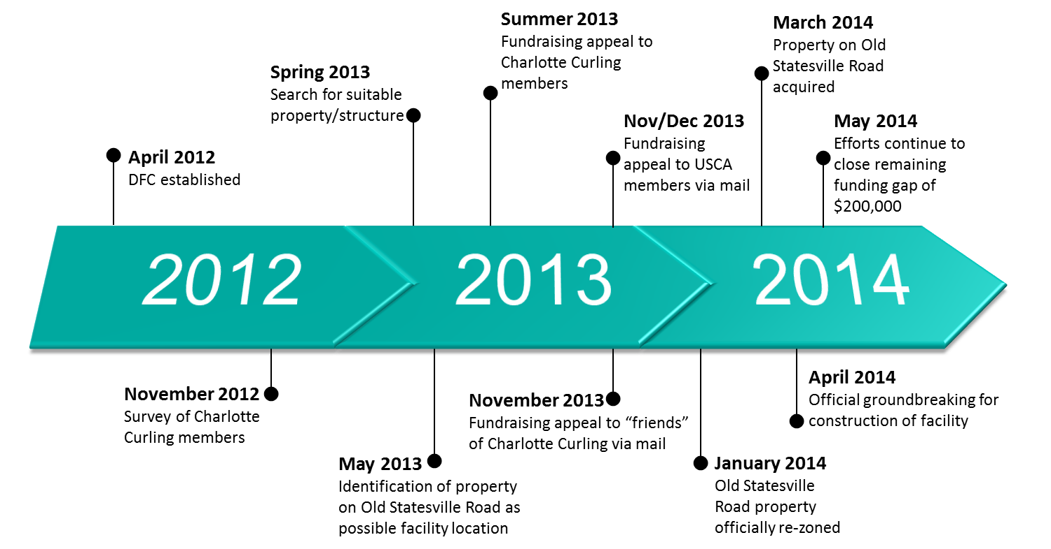

Projection of Business Future

The United States has the fastest growing number of curlers of any country in the world. Every four years, significant additional growth is driven by the Winter Olympics, resulting in high demand for curling events in the Charlotte area. The CCA is committed to becoming a thriving and self-sustaining organization that offers curlers of all abilities and ages recreational and competitive curling, respecting the spirit and traditions of the sport. While only a small portion of those who try curling actually become members at this time, the CCA dedicated facility will allow for far more curling opportunities and a better curling experience, which will increase the membership conversion rate, allow new market segments to join, and influence former members to return. Accordingly, the membership of the association is expected to increase by 415% over the next six years, with the largest increase in the Young Adult, Senior, Family and Youth membership categories:

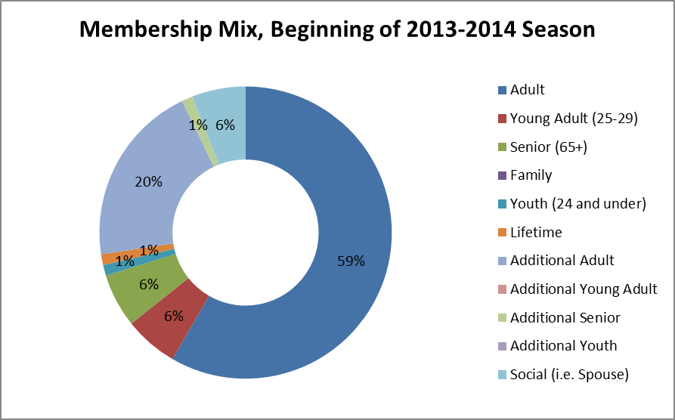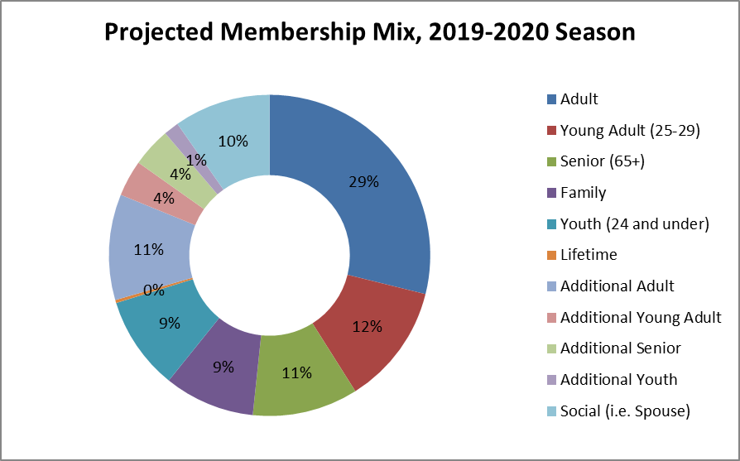

Financial Summary

The Charlotte Curling Association has produced excess revenue in every year of its existence. This is unusual for a non-profit organization and reflects the strong demand in the area and the efficient management principals employed by the Board of Directors. This excess revenue (i.e. net profit) throughout the history of the organization is shown below:

The revenue is even more significant in light of the circumstances under which the organization has operated during its four-year history. In 2010, total income was $10,924, which was spent among ice rental costs ($9,947), rock rental fees ($600) and legal fees, postage and insurance ($137). In 2011, the organization moved from the Pineville Ice House to the Extreme Ice Center, which allowed more frequent and reliable curling. However, ice rental costs increased in late 2011 which caused a lower amount of excess income in 2012. From 2013 until the present, the need for additional ice time has caused the organization to pay approximately $1,000 in rental fees each night. While this is covered by league fees, there is very little positive cash flow from actual game play.

Annual membership fees have remained relatively static at $89 per person annually. This number was raised once during the 2011 membership renewal, from the original membership fee of $79 established in 2010, in order to have necessary funds available to purchase extra "loaner" equipment for new curlers and to have the equipment necessary to hold group events.

Corporate events and Learn to Curl events have had a significant contribution to the group's financial success throughout the past four years. While first-year revenue for these events was only $1,416, the current revenue for these events is $8,888 as of mid-May 2014. Significant income was also earned from bonspiels, or weekend-long curling tournaments, which have earned between $4,000 and $6,000 since 2012. With the advent of the new facility, the excess income from those events will rise noticeably since incremental ice costs will fall to nearly zero.

Finally, the group has been exceptionally strong in its fundraising capacity. Since 2010, the CCA has received cash donations totaling $301,757 and a 0% interest loan of an additional $200,000. In the initial years, some of these excess funds were used as startup costs to acquire club stones, which reduced yearly rock rental fees and provided the association with tangible assets. Other donations will be used to up-fit the building the association will lease as its facility. The total capital cost of the dedicated facility venture is estimated to be $1,700,000, with estimated startup costs of $200,000; details are discussed in the Financial Plan section of this document. The Board of Directors has decided to minimally equip this facility at first to keep a reserve of liquid assets, in case membership income does not grow as expected in the first few years. The chart below shows the projected revenue, expenses and net profit/loss over the next six years:

 | 2014-15 | 2015-16 | 2016-17 | 2017-18 | 2018-19 | 2019-20
Revenue | $154,375 | $179,380 | $196,295 | $211,910 | $227,525 | $248,140
Expenses | $179,029 | $194,484 | $192,531 | $197,851 | $197,443 | $201,420
Profit/Loss | -$24,654 | -$15,104 | $3,764 | $14,059 | $30,082 | $46,720

Market Analysis

The biggest opportunities in the sports industry today lie in providing exciting, high-value opportunities for sports fans – high-tech recreational gear at reasonable prices, spectator sports ticket packages that represent good value, exercise/fitness services and programs that will appeal to aging baby boomers, and equipment and apparel that provide high value and exciting design. Consumers still want to play, but they want to do so at a reasonable cost. Given that curling provides cardiovascular exercise and recreational and social opportunities at a relatively low cost for membership and equipment, the sport provides excellent value and has the ability to serve the needs of a large segment of the population.

Competitive Analysis

As there are no other curling facilities within a reasonable distance, the CCA has no direct competition for membership within the target area. However, the CCA will face competition in the recreational sports market, within which it comprises a niche market. In order to compete with league-based sports like basketball, softball and volleyball, the CCA will continue to differentiate curling as a unique, fun, inexpensive sport that is accessible to everyone in the Charlotte area.

The CCA will face some competition with other curling clubs across the United States and Canada for its bonspiels and events. Over 200 bonspiels – usually three-day tournaments – are hosted in the United States alone each year, and curlers must decide on which events they will spend their time and money. Past CCA bonspiels have been extremely successful, and as the organization adds additional events it will be critical to choose themes and promotions that attract attention to compete in the curling marketplace.

Market Segments

Within the current membership of the CCA, curlers range from 16 to 80 years old, with a median age of 44. Though several live in the southeastern suburbs of Charlotte near the Extreme Ice Center, most others travel farther to curl, including from as far as Greensboro and Statesville, NC; Greenville-Spartanburg, SC; and Columbia, SC. Many members have moved to the Charlotte area from Canada or the northern United States and had curled before, although in many cases these transplants had no prior curling experience. Nearly all members have a household income higher than the $56,000 median in Mecklenburg County.

Despite some similarities among current members, the target market segments are derived from a large demographic profile. Curlers can be from ages 6 through 90, of either gender, and of any level of education or income. Initial equipment – sliders, brooms and stabilizers – are provided by the CCA, so new curlers have no start-up costs. Curlers may wish to purchase their own equipment as they go forward, but it is not a requirement. This allows the CCA to target a broad market for membership and events. More specific demographics will be targeted based on the goals of each revenue area:

 |  | Market Segment
Member Revenue | Youth | Ages 6-24; either gender; students through college and youth groups/organizations in Charlotte area
 | Young Adult | Ages 25-29; either gender; young professionals with disposable income in Charlotte area
 | Adult | Ages 29-65+; either gender; professionals and sports enthusiasts in Charlotte area
 | Senior | Ages 65-90; either gender; professionals or retired persons in Charlotte area
 | Family | Ages 6-90; families seeking recreational activities in Charlotte area
Bonspiel Revenue |  | Ages 18+; either gender; curlers from clubs throughout North America, especially previous bonspiel attendees. Specific demographics may be further defined as bonspiels are added for men, women, seniors, etc.
Special Events Revenue | Learn to Curl Sessions | Ages 6-90; either gender; anyone with interest in curling with little to no experience in Charlotte area
 | Corporate Events | Ages 18-70; either gender; groups from small through large Charlotte-area businesses interested in a unique experience for a party or teambuilding event
 | Private Events | Ages 6-90; either gender; curling enthusiasts, youth groups, school groups, disabled persons, families (for reunions, birthday parties, etc.) in Charlotte area
Concession Revenue |  | Ages 6-90; either gender; all club members, visitors, and event attendees
Advertising and Sponsorship Revenue |  | Ages 25-70; either gender; small through large Charlotte-area business and/or marketing professionals seeking a unique, low-cost method of advertising and/or philanthropy
Fundraising and Donations |  | Ages 18-90; either gender; club members, curling clubs, businesses and individuals with interest in curling and/or philanthropy across North America

Entry Barriers

The Charlotte Curling Association is the only curling club in the Charlotte area, and the barriers to creation of a similar organization in the area are very high. The Charlotte area currently contains only two ice centers, and both have extremely busy schedules. The formation of an official curling club requires ice availability, a significant amount of capital and effort, and membership in the Grand National Curling Club (GNCC). In such a small niche market, it is likely that the GNCC would discourage competition within a city that already has a curling organization. While it is possible to purchase equipment and curl without GNCC support, members of the hypothetical club would not be able to compete at other clubs or at an official level. Without these competitive options and due to the existing dominance of the CCA in the region, startup would be very difficult and longevity would be unlikely.

Sales and Marketing Strategy
In order to support its mission, the Charlotte Curling Association has an integrated multi-faceted sales strategy, which largely focuses on membership recruitment and retention, execution of bonspiels and special events, and attainment of donations, advertising revenue and sponsorships. In order to facilitate the sales strategy and promote the sport of curling, the marketing strategy focuses on building awareness and reputation, promoting the club and its events, and fostering symbiotic relationships with other curling clubs. These plans are detailed in the sections below.

Product/Service Strategy

The CCA provides the only curling opportunities in the Charlotte area, which creates a unique offering in the market. The organization currently offers Learn to Curl events for prospective curlers, as well as memberships for those who wish to further pursue the sport. Following the facility opening, the CCA will be able to increase the number and frequency of LTC events, which will create a larger pool of potential members.

Various events will be offered throughout the curling season, including corporate and private events. Corporate events can serve as parties or teambuilding sessions, and will be positioned as a unique, low-cost opportunity for local businesses to provide their employees with a fun, active experience in which everyone will be able to participate. Private events could include birthday parties, school events, youth group outings, and more; the flexibility of these event options will allow the CCA to address the needs of the market on demand.

The CCA currently holds one to two bonspiels, or weekend-long curling tournaments, per year. That number is expected to increase to three per year starting in the 2014-15 season, then four starting in 2015-16. These events will allow the association to expand its reach to additional clubs and curlers throughout North America. This will boost awareness and create self-sustaining bonspiels, which will require only a small budget to promote.

In the B2B market, the CCA will offer many sponsorship and advertising opportunities in its new facility to raise funds toward lease payments and operations. Sponsorship and advertising categories include the following:
- Building sponsorships: Naming rights, lounge, locker rooms
- Billboard Advertising: Small, medium, large options
- Scoreboard Advertising: Banner ad, logo
- In-ice Advertising: Center ice logo, front of house, house logo, on the button, front of hack

Pricing Strategy

The current price for Learn to Curl events is $25 per person. Membership is $89 per person annually, and each league costs approximately $210. The membership price is currently waived for the first year for new curlers who join a league.

When the CCA facility opens, the pricing structure will change, with the annual membership cost increasing for most members and league fees decreasing to approximately $75 per league. Based on a historical average of 2.6 8-week leagues per person per year, most current members will pay approximately the same amount for the same amount of curling. This will allow the organization to easily retain its current members. Members will have an improved curling experience and more curling options, which are likely to lead to an increased perception of value and a higher average spend per person. The projected membership pricing structure is shown in the following table:

Membership Category | Price
Adult | $300
Young Adult (25-29) | $250
Senior (65+) | $250
Family | $700
Youth (24 and under) | $125
Lifetime (large donation) | $0
Additional Adult | $250
Additional Young Adult | $200
Additional Senior | $200
Additional Youth | $75
Social (i.e. Spouse) | $50

The CCA will adopt a penetration pricing strategy to attract new curlers. While the initial Learn to Curl price will remain $25 per person, an advanced LTC will be offered for $15. A follow-on “Rookie League” will allow four additional weeks of curling at $40 without additional commitment. New curlers will then be offered reduced rates for membership and league play.

Corporate and private event prices will vary based on event needs, duration, number of people, etc. An average corporate event, using the entire facility for 40 people over 3 hours, would cost approximately $2,500. A minor event, such as a birthday party, would cost approximately $750. These prices are competitive with nearly all other venues, and are lower than most corporate activity-based event options.

Bonspiels are expected to maintain the current prices of approximately $380 per four-person team. This price is competitive with other bonspiels around the country.

Advertising and sponsorship prices will be charged annually, and are available at many price points to fit most marketing budgets. Billboard, scoreboard and in-ice advertising prices range from $50 to $250 annually, not including sign costs. The larger building sponsorship prices will be determined at a future date by the Dedicated Facility and Fundraising Committees.

Recruitment and Retention Strategy

In order to successfully sustain the new facility, the goal of the CCA is to increase its membership by 415% within the next six years. Over the 2014-2015 curling season, the Membership Committee plans to recruit an additional 63 members. The marketing tactics detailed below will be employed to attract new curlers to Learn to Curl events and provide an introduction to curling.

Once a potential member has attended his or her first LTC or corporate/private event, he or she will be offered additional options to engage with curling and the club – for example, a lower-priced advanced LTC and a four-week rookie league. Neither of these options will require additional commitment, which allows a more comprehensive and enjoyable learning experience for the new curler. Exposure to these additional curling opportunities, in addition to the initial membership and league discounts, will increase the likelihood that the new curler will become a long-term member.

It will be very important to engage the new member with development opportunities, managed by the Player Development Committee. Additional training will help the new member become more comfortable with the game and he or she will then be ready to sign up for additional leagues. After the new member is fully trained and engaged with the club, he or she would become a potential candidate for donations or volunteer activities; however, it will be very important to wait until that level of engagement to solicit any commitment.

In order to retain members, frequent training and development opportunities will be key, especially for those who wish to pursue higher levels of competition.

The CCA is planning a Level I instructor course this year. This will provide certification for the Association’s own instructors which will validate the instructional program, and also allow regional instructors to participate and gain a further appreciation of CCA’s unique features.

The CCA will host curling clinics such as the Hot Shots Curling Camp which was held last summer and future similar events.

The CCA will host in-house clinics to teach basic and advanced strategy, delivery techniques, skipping and similar topics.

Fundraising/Sponsorship Strategy

Currently, the fundraising strategy of the CCA has several components:
- Letter and e-mail fundraising campaigns to the USCA membership, friends of the CCA, and CCA membership. The first round has been completed
- Fundraiser engaged to obtain sponsorship of specific necessary equipment such as the ice scraper, furniture, or kitchen equipment from corporate or private sponsors
- Fundraising events such as Comedy for Curling, a comedy event held in May 2014 which raised over $5,000
- Solicitation of advertisers for billboards and other display areas of the ice area by preparing a brochure and distributing it to interested local businesses and online
- Application for various grants applicable to curling and to our objective of inclusion of disadvantaged and disabled people
- Application to the World Curling Federation for their interest free loan program. This loan is repayable in eight equal installments in the third through tenth years of the loan term
- Request for curling equipment for kids and junior curling from Goldline Curling Supplies
- Minor in-house raffles and draws

Bonspiel and Special Events Strategy

Bonspiels are an important source of revenue and serve to promote the CCA both locally and in the larger North American curling community. The CCA has already gained a reputation for running a well-organized, competitive and fun bonspiel with the initial three Grits ‘n’ Granite events. In the first year of operation of the new facility, the CCA will limit itself in bonspiels in order to concentrate on first year club operations. Although this strategy will somewhat limit revenue, it will allow the association to adjust to the increased volunteer participation required to maintain the facility and run leagues and events throughout the season. In following years, the CCA will host additional bonspiels.

Hosting of special events within the facility has proven to be a major source of revenue for most curling clubs. The CCA already receives numerous requests for special events from businesses and private individuals. The availability of the CCA to host these events is currently limited by lack of ice time, but with the new facility, these programs will be limited only by volunteer personnel to organize, instruct and conduct the events as most will be requested on afternoons and weekends. It is expected that the CCA will host approximately two corporate events and one private event per month. These will generate approximately $2,500 and $750 per event, respectively.

Marketing Strategy

The current goals of the Marketing Committee are to:
- Build CCA awareness and reputation in Charlotte and beyond to boost support/sponsorship of and donations toward the dedicated facility
- Promote club, Learn to Curls and other events across multiple target audiences to support membership drive
- Foster encouraging relationships with other southeastern curling clubs through increased communication, positive attitudes and cross-promotion

These goals closely align with overall CCA goals, and the Marketing Committee provides support for objectives across several other groups in the organization to create a cohesive approach and unified position in the marketplace.

The committee consists of a committee head and five marketing areas critical to CCA success: Internal Communications, External Communications, Social Media, Website and Branding/Collateral. The plan within each area is detailed in the sub-sections below.

Internal Communications Strategy

Ensuring that all members are informed about the latest club news is extremely important, and the CCA engages members via a weekly email newsletter and occasional official club emails on key topics. The internal communications team also fields incoming emails to the appropriate CCA volunteer. The team will continue these activities after the new facility opens, ensuring that the growing group of members has the latest information about the CCA.

External Communications Strategy

The external communications team is responsible for media relations, community relations, publicity events, advertising and video creation. The CCA has had regular media attention since its creation in 2010, due to the unique and interesting aspects of curling. This includes a front-page article released by the Charlotte Observer on April 5, 2014. Currently, the team is producing the first-ever official CCA video, which will be used to build awareness and influence donations and sponsorships. The team also executed the official groundbreaking event in April 2014, which involved local community leaders, politicians and media. The latest project is the promotion of a May 21st fundraising event, “Comedy for Curling”, which is hosted by the Comedy Zone, a popular comedy venue in Charlotte. All ticket sales will go toward the funding of the facility.

Publicity event creation and participation, event promotion, and various forms of advertising are planned in advance of the facility opening, including the following activities:
- Large print advertisement(s) in Charlotte Magazine (popular local magazine with large circulation), promoting LTC events and new facility
- Event sponsorship – investigating event options with Charlotte Magazine, the Charlotte Checkers hockey team, local bars/restaurants broadcasting curling events
- Medium print advertisement in Creative Loafing (free local publication with large circulation targeting unique audience), promoting LTC events and new facility
- Article in US Curling magazine and Grand National Curling Club Newsletter announcing opening to curlers in the US
- Possible TV commercial, to be filmed in August and promoted on local channels
- Communication with local businesses surrounding new facility, announcing community open house event
- Press releases and media outreach to announce new facility and Grand Opening/media open house event
- Grand Opening event execution

Following the Grand Opening, additional advertising placements will occur to boost LTC attendance. One particular targeted program will be a LivingSocial and/or Groupon deal, which will allow the CCA to attract a very large audience with a discounted offer.

Social Media Strategy
Social media marketing is a key component of the CCA marketing strategy, supporting all other areas of the organization. The CCA has a strong presence on Facebook, with 1,135 likes in May 2014, as well as a significant presence on Twitter (over 600 followers) and Flickr (over 3,000 photos). The Dedicated Facility Committee discusses its latest accomplishments through a WordPress blog linked with the official Charlotte Curling website. Overall, the CCA has a notable social media following due to its frequent, relevant updates and occasional Facebook promotions. Surrounding the opening of the facility and beyond, social media will play a large role in communication and promotion of events and updates. The social media team will continue to create regular Facebook and Twitter promotions and ads to boost CCA awareness and engage new followers, especially to promote LTC events.

Website Strategy

The CCA website, charlottecurling.com, is used for marketing to the general public and as an informational tool for its members. The website advertises Learn to Curl events, leagues and bonspiels, as well as fundraising and other club events and promotions. It provides a method for members, potential members and donors to electronically register and pay for membership, leagues and events, and to submit donations. The clean, simple design of the site encourages visitors to explore information about the club, its purpose and latest updates, and information about other clubs in the Southeast and bonspiels nationwide to help promote the sport of curling as whole.

The website will become increasingly important as a source of detailed information in late 2014, when promotions and advertising supporting the membership drive will augment traffic. The website team has purchased Curling Club Manager which is a software package specifically designed to manage functions in curling clubs such as membership, league management, league draws, etc. CCA will continue to ensure the website is up-to-date and functional by maintaining strong communication links with other committees and other clubs.

Branding/Collateral Strategy

The branding and collateral team focuses on maintaining the integrity of the CCA visual identity, through logos, branding elements and marketing collateral. The CCA produces various brochures, flyers, invitations and other visuals to support its marketing and sales efforts across committees. As the organization grows, it is expected that needs for visuals as well as equity alignment will increase.

Differentiation

In addition to being the only curling organization in the Charlotte area, the CCA is one of the few curling clubs in the southeastern United States. When the CCA dedicated facility opens, it will be one of only two such facilities in the Southeast. The association is fortunate to have many committed and talented individuals who have contributed their business, organizational and curling skills to progress to the point of building a facility in such a short time. The warm, energetic and dedicated membership is the primary reason for the organization’s success as well as a key differentiator. The best demonstration of that is the continued success of the Grits ‘n’ Granite bonspiel, an annual event first held in August 2012. While the warm climate in Charlotte initially attracted curlers across North America to the bonspiel, the event experience helped the CCA develop a unique reputation as a fun, hospitable, professional curling club. The event immediately became one of the most popular among North American curling clubs, and quickly sold out in both 2013 and 2014. This competitive advantage, coupled with the improved experience of dedicated curling ice, will ensure success of future tournaments.

Locally, curling will be promoted as one of the only sports that nearly everyone can play together. It is a unique, energetic family opportunity; a fun date night; and a chance for inexperienced players to actively learn from the experienced. In addition, it is one of the few sports which requires little to no equipment and can be played for a very low cost.

Operations Plan

The CCA is positioned to be the premier curling club in the southeastern United States. After four years of very successful club operations in rented arena space, the organization is planning to build a dedicated curling facility, which will allow the CCA to grow to its full potential. The operations plan for the new facility is outlined in the sections below.

Location

The current mailing address of the CCA is:
145-B Cupped Oak Lane
Stallings, NC 28104

The address of the Extreme Ice Center, the current curling location, is:
4705 Indian Trail Fairview Rd
Indian Trail, NC 28079

Following the facility opening, both the mailing address and curling location will change to an address which is far more centrally located in Charlotte:
6525 Old Statesville Rd
Charlotte, NC 28269

Operation

The current regular operating hours of the Charlotte Curling Association are Tuesdays from 11:10 AM – 1:10 PM and Fridays from 7:30 PM – 11:30 PM. Ice availability on Tuesdays and Fridays is subject to the schedule of the Extreme Ice Center. As the ice center is open year-round, CCA is able to curl throughout the year at a consistent cost.

Following the opening of the new facility, the operating hours of the CCA will be Mondays through Fridays from 4:00 PM – 12:00 AM and Saturdays and Sundays from 9:00 AM – 12:00 PM. In order to control operating costs, the association will adopt a traditional curling season, from October 1 to April 15 annually.

Employees

Currently CCA has no paid employees. It is expected that it will continue as a volunteer-managed organization through the foreseeable future. The Board of Directors will continue to be comprised of volunteers, and the Board will appoint the following volunteer positions as needed:
- Dedicated Facility Committee Head
- Membership Committee Head
- Fundraising and Sponsorship Committee Head
- Marketing Committee Head
- Corporate / Special Events Committee Head
- Ice and Equipment Committee Head
- League Coordinator
- Learn to Curl Coordinator
- Player Development Committee Head
- Youth Curling Coordinator
- Disabled Curling Coordinator
- House Committee Head
- GNCC Representative

Space

The ice area of the facility, including walkways surrounding the four-sheet ice surface, will be approximately 11,235 square feet. The mechanical shed will be approximately 600 square feet. The warm area including washrooms, food and beverage area, office and storage will be approximately 3,500 square feet.

Capacity

Based on four sheets of ice with eight players per sheet, the curling capacity of the facility will be 32 players per two hour period. During the opening hours stated above, 34 draws could be played each week for a total capacity of 1088 players per week.

Including players, spectators and volunteer staff, the total capacity as determined by the Fire Marshall will be slightly less than 300.

Financial System

The CCA Treasurer and a volunteer bookkeeper will process all day-to-day financial transactions for the association. A volunteer accountant will produce financial statements and tax returns.

Computer System

The CCA has purchased club management software, Curling Club Manager, which will manage functions including member registration, league management, league standings, league substitution list, club calendar, website, mass email functions, sponsor ad space tracking, photo gallery, and more.

Tools and Equipment

Necessary ice preparation tools include the following, much of which is currently owned by the association:
- Hoses
- Ice king
- Nipper
- Hand scraper
- Four pebble cans
- Assorted pebble heads
- Two 8’ mops
- One 8’ sweeping brush
- Two Corn Brooms
- Water RO treatment and storage system
- Water Heater
- Rock Boxes
- Thermometers

In addition, the organization owns the following equipment necessary for curling:
- 65 curling rocks and 66 handles (1 spare)
- Eight hacks
- Four scoreboards
- One boot master
- One adjustable measuring device
- One six-foot measuring device
- Assorted club sliders
- Assorted club grippers
- 32 club brooms
- 12 curling stabilizers

Miscellaneous equipment which will need to be acquired includes a toolbox of light carpentry and maintenance tools and one computer and one printer for the CCA office.

Furniture

Furniture in the new facility will need to be purchased, consisting of:
- Four round tables (to seat eight each)
- 32 chairs to match tables
- Additional seating, stadium or freestanding
- Folding tables
- Bar stools
- One Office Desk and Chair
- Two Office Chairs
- One Filing Cabinet

Displays

A roadside advertising sign and assorted notice boards for the warm room will be purchased.

Permits and Licenses

Building permits have been approved and construction is underway. It is expected that the ice slab cooling pipe and headers will be installed and the concrete slab poured by approximately September 19, 2014. A Certificate of Occupancy should be granted in early October 2014.

A business license and bar licenses will be required to operate the new facility.

Insurance

The following types of insurance will be purchased:
- Errors and Omissions to protect the Board of Directors, with a coverage amount of $1,000,000
- Employee theft coverage in the amount of $750,000
- Building, Fire, Damage and Theft Insurance, with a coverage amount of $1,550,000
- Contents Insurance with a coverage amount of $100,000
- Liability Insurance, with a coverage amount of $2,000,000

Financial Plan

The CCA will lease, up-fit and operate a dedicated ice facility by November 1, 2014. This financial plan outlines the associated costs and funding, and will be divided into two parts – the capital budget for building and up-fitting the facility and the operating budget for the association.

Capital Budget

The total capital cost of the building project is estimated to be $1,750,000. The lessor, D&E Properties of NC, RLLP, also a CCA member, has committed to the construction of a building to house a four-sheet curling club as per the attached floor plan (Attached as Appendix 1). The CCA has committed $400,000 as its initial share of the capital cost and an additional $120,000 over the following six years in addition to lease costs. At that point, the CCA would purchase the facility using traditional bank financing. The title does not transfer until the CCA is able to take this action. These latter payments are reflected in the operating budget in the following section.

Additionally, the CCA has purchased major equipment such as an Ice King ($12,750), Reverse Osmosis water treatment and storage equipment ($6,800), a nipper and other curling specific equipment ($5,700), ice paint ($1000) as well as a large number of smaller purchases such as furniture and other items in order to begin operations in the new facility by November 1. Total initial furnishings and equipment costs are expected to be approximately $36,000.

Operating Budget

The operating budget for the next six years is attached as Appendix 2.

Revenue

Revenue will be obtained from six main sources:

- Member revenue derived from membership dues ranging from $125-300 per member (with household and family plans available) and league fees of $75 per eight-week league. The membership dues were specified above on page 11.

- Bonspiel revenue, derived from three bonspiels in the first year and four bonspiels in following years. Each bonspiel is projected to have 32 teams with an entry fee of approximately $380 (80% to revenue)

- Special events revenue, generated from Learn to Curl sessions, corporate events and private events hosted using CCA facilities and volunteer personnel

- Concession revenue, the net profit from bar sales and merchandise sales of pins, shirts and other items

- Advertising and sponsorship revenue, generated from the sale of advertising space within the facility and sponsorship of various elements of the facility, including “adopted” rocks, facility naming rights and more

- Fundraising and donations, derived from an ongoing campaign to supplement other revenue, with a goal of moving the CCA into a position to self-finance the new facility as quickly as possible

Expenses

Expense items include lease/mortgage repayment, WCF loan repayment, utilities, operational expenses, taxes, insurance, marketing costs, administrative expenses and dues to GNCC and USCA.

Funding Sources

Funding in the current fundraising drive comes from the following sources:

$400,000 | This donation is a cash donation of $200,000 and a 0% loan of $200,000 to be repaid after the repayment of the WCF loan. This donation and loan has been made by a CCA member.
$200,000 | This is a WCF loan routed through the USCA. It is a 0% interest loan payable in 8 equal payments after year three of the loan. The application for this loan is in process.
$50,000 | Mail campaign to USCA members. This campaign is now completed.
$75,000 | Donations from other current CCA members. The first round of this campaign has been completed and will continue as an annual event.

Cash Flow Projection

Cash flow projections are shown below:

Cash Flow | Initial | 2014-15 | 2015-16 | 2016-17 | 2017-18 | 2018-19 | 2019-20
Surplus/Deficit | 69,742.37 | -24,654 | -15,104 | 3,764 | 14,059 | 30,082 | 46,720
Cash Available |  | 45,089 | 29,985 | 33,749 | 47,807 | 77,889 | 124,609

Appendices

Appendix 1 – Building Layout

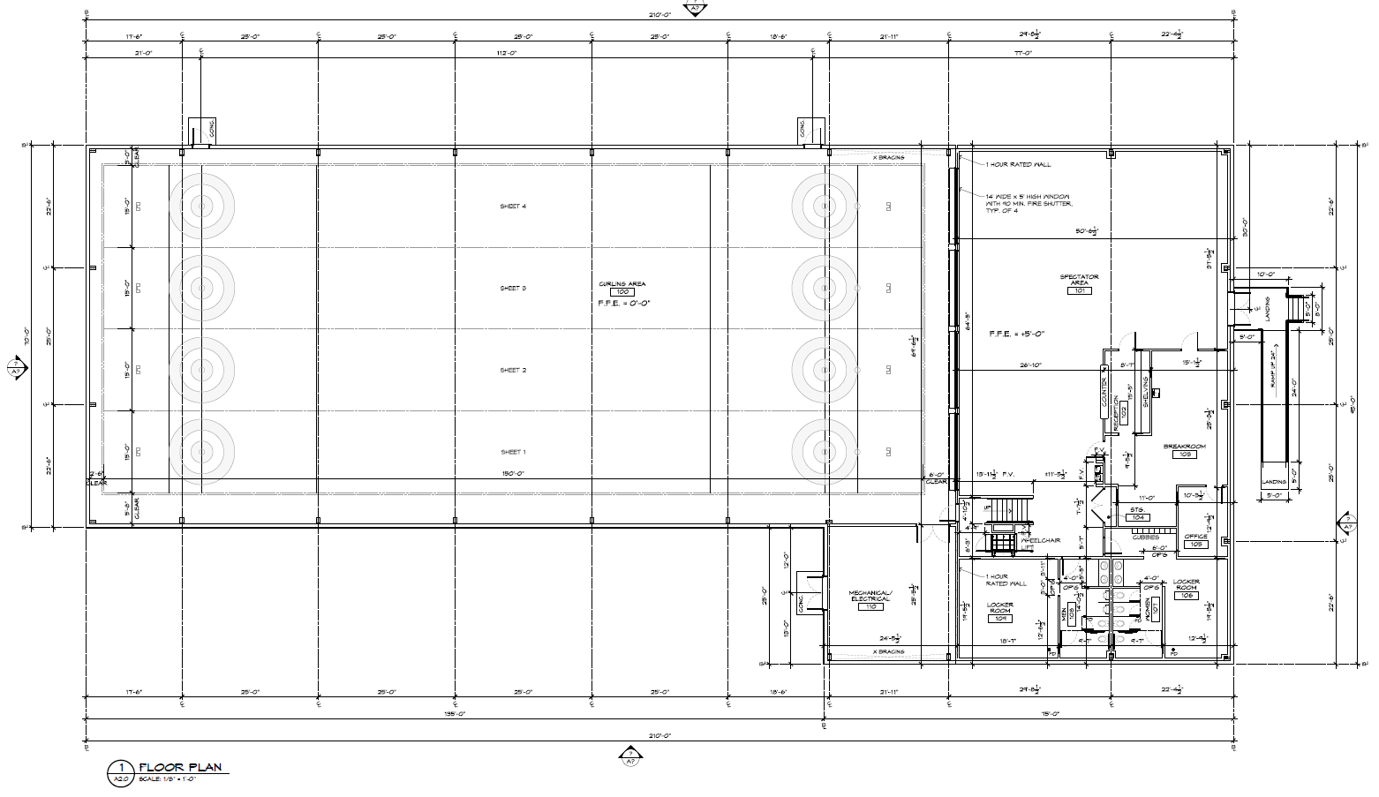

Appendix 2 – Six Year Operating Budget

Charlotte Curling - Operating Budget_Version 4.11
9/10/2014 | 2014-15 | 2015-16 | 2016-17 | 2017-18 | 2018-19 | 2019-20
Revenue
Membership Revenue | $31,950 | $48,050 | $58,825 | $68,500 | $78,175 | $87,850
League Revenue | $20,550 | $32,955 | $39,195 | $45,435 | $51,675 | $57,915
Bonspiel Revenue | $2,000 | $8,000 | $10,000 | $10,000 | $10,000 | $10,000
LTC, LTC+ | $3,625 | $3,625 | $3,625 | $3,625 | $3,625 | $3,625
Special Events | $25,250 | $30,250 | $30,250 | $30,250 | $30,250 | $35,250
Concessions profit (net revenue) | $10,000 | $11,200 | $12,400 | $13,600 | $14,800 | $16,000
Advertising Revenue | $10,000 | $10,000 | $10,000 | $10,000 | $10,000 | $10,000
Fundraising/Donations | $20,000 | $20,000 | $20,000 | $20,000 | $20,000 | $20,000
AV Donation | $25,000 | $0 | $0 | $0 | $0 | $0
Grants | $6,000 | $3,300 | $0 | $0 | $0 | $0
Interest from Donor Loan Investment | $0 | $12,000 | $12,000 | $10,500 | $9,000 | $7,500
Total Revenue | $154,375 | $179,380 | $196,295 | $211,910 | $227,525 | $248,140
Expenses
Lease payment | $70,000 | $84,000 | $84,000 | $84,000 | $84,000 | $84,000
WCF Loan Repayment | $0 | $0 | $0 | $0 | $0 | $0
Professional Fees | $6,500 | $4,000 | $4,000 | $4,000 | $4,000 | $4,000
Payroll | $0 | $0 | $0 | $0 | $0 | $0
Utilities
Electricity | $29,081 | $30,572 | $31,489 | $32,433 | $33,406 | $34,409
Phone, TV, Internet | $1,650 | $2,039 | $2,101 | $2,164 | $2,229 | $2,295
Water and Sewer | $1,300 | $1,339 | $1,379 | $1,421 | $1,463 | $1,507
Operational Costs
Ice Installation and Maintenance | $3,300 | $3,399 | $3,501 | $3,606 | $3,714 | $3,826
Equipment Maintenance and Repair | $500 | $2,500 | $2,575 | $2,652 | $2,732 | $2,814
Furnishings and Equipment Purchase | $0 | $3,300 | $0 | $0 | $0 | $0
AV Equipment | $25,000 | $0 | $0 | $0 | $0 | $0
Rock Rental | $500 | $0 | $0 | $0 | $0 | $0
Landscaping | $3,500 | $3,605 | $3,713 | $3,825 | $3,939 | $4,057
Cleaning | $1,500 | $1,545 | $1,591 | $1,639 | $1,688 | $1,739
Taxes | $400 | $21,835 | $22,135 | $22,435 | $22,735 | $23,035
Insurance | $6,565 | $6,765 | $6,965 | $7,165 | $7,365 | $7,565
Marketing expense | $10,600 | $7,600 | $4,600 | $6,000 | $2,000 | $2,000
Office Supplies | $1,500 | $1,545 | $1,591 | $1,639 | $1,688 | $1,739
Clinics | $2,500 | $2,575 | $2,652 | $2,732 | $2,814 | $2,898
Travel | $1,200 | $1,236 | $1,273 | $1,311 | $1,351 | $1,391
Dues (USCA & GNCC) | $4,220 | $7,608 | $9,903 | $11,263 | $12,623 | $13,983
Bad Debt | $1,364 | $1,794 | $1,963 | $2,119 | $2,275 | $2,481
Miscellaneous | $7,849 | $7,228 | $7,100 | $7,448 | $7,422 | $7,682
Contingency (Available from loan to D&E | $0 | $0 | $0 | $0 | $0 | $0
Total expenses | $179,029 | $194,484 | $192,531 | $197,851 | $197,443 | $201,420
Net Surplus/Loss | -$24,654 | -$15,104 | $3,764 | $14,059 | $30,082 | $46,720

